TOP 10 MOST FAMOUS CRIMINOLOGY OF ALL TIME
One of the more fascinating studies is the study of the criminal mind. Criminology is the study of behavior in criminals, as well as the cause, nature, extent and control of criminal behavior in society. There are a number of programs related to criminology, and you can learn about the specific study of crime, and how it affects individuals and society as a whole. Here are 10 famous criminologists:

- Cesare Beccaria: Ceseare, the Marquis of Beccaria-Bonesana, is widely regarded as one of the first to look at theories of crime and society. He lived during the 18th Century, in Italy. Originally, he was thought to have a career in mathematics, and he studied economics. However, he became interested in the nature of crime, and was considered a reformer during the Enlightenment, speaking out against the death penalty. His most famous work is the brief, “On Crimes and Punishment,” which was the first publication to marshal arguments against the death penalty. It also advocated a reform of the criminal justice system. Beccaria believed that punishment should be preventative, and that certainty of punishment had more impact in deterring criminal behavior than the severity of the punishment.
- 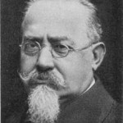Cesare Lombroso: Unlike some criminologists who thought that crime was part of a tendency in human nature, Cesare Lombroso believed that there were genetic predispositions for crime, as well as thinking that physical characteristics might indicate that someone had criminal tendencies. Lombroso brought the idea that someone could be “born criminal” into public acceptance. He postulated that criminals were evolutionary regressions, pointing out different physical characteristics of criminals that suggested that the criminal had devolved. Lombroso spent time compiling anthropological data, measuring different criminals’ physiological features and trying to compile a scientific methodology for predicting criminal behavior.
- 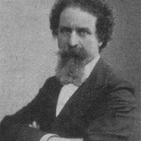Enrico Ferri: One expected a student of Cesare Lombroso to be interested in the physical characteristics of criminals. However, Italian sociologist Enrico Ferri, though studying under Lombroso, did not focus on physiological factor contributing to criminal behavior. Instead, he was more interested in the economic and social factors that caused crime. He believed that by tweaking the economic and social factors that led to crime behaviors, it would be possible to prevent crime, rather than having to always punish it. He was considered a radical, and he was an outspoken socialist. One of his most famous works was Criminal Sociology, a study of what societal factors contribute to criminal behavior. His theories formed the basis of the 1921 penal code adopted by Argentina.
- 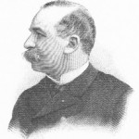Alexandre Lacassagne: The French physician Alexandre Lacassagne became interested in crime and psychology through his work. He established the Lacassagne school of criminology, based in Lyon, France. His school of criminologist thought was the rival to Lombroso’s school in Italy. Lacassagne’s main problem with Lombroso was the idea of being born a criminal. As a physician, Lacassagne was suspicious of a purely physiological cause to criminal behavior. Instead, he insisted that social factors had more to do with criminality than heredity. Lacassagne also divided criminals into different types: thought, act and instinctual. He did, however, place some importance on phrenology, and this is part of why Lacassagne’s contributions to criminology have been largely overlooked until modern times.
- 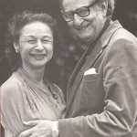Hans Eysenck: As a young man, Hans Eysenck moved from Berlin to England. He opposed the Nazi party, and was determined to get out of Germany. He was a psychology professor for quite some time. He studied personality, and the genetic factors that influence personality. He looked at psychoticism, and that is part of his interest in criminology. Eysenck wrote a book called Crime and Personality, and also looked drug experimentation. He also wrote about behavior therapy and personality as it relates to intelligence. His theories contributed to knowledge of criminal personalities, and many of his theories were developed with the help of his wife, Sybil.
- 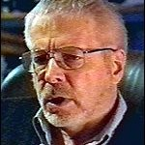Robert Hare: One of the most famous criminologists is Robert Hare, who considers questions of psychopathology and psychophysiology. He has done extensive research into the qualities of a psychopath, and wrote an interesting couple of works on the subject, Psychopathy: Theory and Research and Without Conscience: The Disturbing World of Psychopaths Among Us. Hare postulated that sometimes you might not always be able to identify murderers, since some are psychopaths and can be quite charming. However, he did develop a checklist to help psychologists identify psychopathy. His checklist is considered one of the most reliable metrics to measure psychopathy.
- 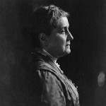Jane Addams: Born into a prosperous family, Jane Addams became interested in the plights of the less fortunate. She was not interested in marriage, and did not wish to pursue the expected path of someone born to her station. Instead, she became an activist and a lecturer. She was interested in studying the causes of crime, and believed that poverty and society contributed to crime. Addams encouraged studies of the underlying causes of crime. In an effort to prevent crime, she helped found the U.S. Settlement House Movement, believing that economic security could help battle crime. Addams was awarded the Nobel Peace Prize — the second woman to receive the prestigious award.
- 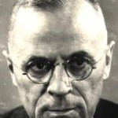Edwin Sutherland: As one of the most influential American criminologists of the 20th Century, Edwin Sutherland has left his mark on the study of criminals. He authored Principles of Criminology, a textbook about the basics of criminology. Sutherland created the term “white collar criminal”, and postulated about criminal differences between classes. He believed that criminal behavior developed from associating with those who committed crime, and that delinquency was more likely to result from learned behaviors. Motivations and technical knowledge, according to Sutherland, were likely to be learned from those who commit crimes. He also suggested that social disorganization and conflict contributed to crime.
- William Julius Wilson: A prominent sociologist, William Julius Wilson has taught at the University of Chicago and Harvard. His work has largely revolved around race, looking at some of the reasons that crime rates differ according to race. He wrote a book called The Truly Disadvantaged, as well as a book called The Declining Significance of Race. Wilson has studied urban sociology and some of the factors that contribute to crime, especial urban poverty. He has pondered the question of the incidence of poverty amongst blacks, and wondered if that contributes to the crime rate. Wilson has also studied discrimination and how that relates to crime, housing, hiring and education.
- 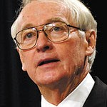James Q. Wilson: The high profile James Q. Wilson is a member of the American Enterprise Institute was a former chair of the White House Task Force on Crime. He is a political science professor, and is known for his public work on crime, and his theories related to public policy and crime. His theories and work have included preventing delinquency among children, and how morality relates to crime. He has also been a member of the Attorney General’s Task Force on Violent Crime.

